**URL: http://alnajah-hospital.com/English.asp**

We Concentrate on subspecialties  through the main specialicities and we provide our Clients with highly specialized medical care. We believe in playing an effective role in the society serving and development. We held many symposiums for specialists and public to support the continuous medical education.  
  
We look forward for serving Jordanian society and Jordanian women and try our best to develop our medical services to meet the needs and expectations of the clients.

Our Aims

Our message is to offer the best Medical care in Jordan ,we concentrate on the subspecialties and we are special in Gynaecology & Obstetrics and Fertility.  
  
Our Aim is to meet the needs and expectations of our patients:   
-We work as a team.  
-We cooperate with foreign experts.  
-We use the new technology.  
-We develop a professional and flexible administration.   
-We employ a well trained highly qualified medical a nursing staff.

**The Work Philosophy**  
-Patients First.  
-With Help of the God we will care for you.   
-Creating a good atmosphere for work.  
-Care for values and morals of occupation.  
-Serving the Society through our work.   
-Continuous education and training of the medical and nursing staff.

Doctors credentials:

**Dr. Raji Adwan Al-Nueimi**

**Personal Information:**

**Name: Dr. Raji Adwan Al-Nueimi 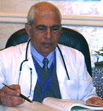  
Scientific Qualification:  
* Bachelor of medicine Sofia university Bulgaria   
* PHD-in Obstetrics, Gynecology & Infertility - Sofia   Bulgaria   
* Jordanian Board in Obstetrics, Gynaecology & Infertility   
* Diploma in Family Planning - Meryland - USA   
  
Training Courses:   
National and International Training Courses in Ultrasound and Obstetrics & Gynaecology.  
  
Experiences:   
* Consultant in Obstetrics, Gynaecology & Infertility in Princess Basma Teaching Hospitals "formerly".  
* General manager in Al-Qwasmi Hospital for Obstetrics & Gynaecology.  
* Private clinic Irbid .  
* Now he is general manager in Al-Najah Hospital for Obstetrics & Gynaecology.  
  
Membership:   
* Jordanian Society of Obstetrics & Gynaecology.  
* Bulgarian Society of Obstetrics & Gynaecology.**

**Dr. ABDER Razzaq Sharayera**

**Personal Information:**

**Name: Dr. ABDER Razzaq Sharayera 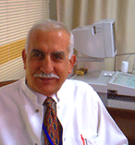  
Scientific Qualification:  
* Graduate from medical school at the University of Heidelberg Germany.  
* Facharzt of Obstetrics & Gynaecology from the medical association of north –Wurttemberg – Stuttgart.  
* Dissertation; Doctor in medicine from the university of Heidelberg   
* Certificate to carry out US examination from the north Wurttemberg association.  
* Cytology certificate to carry out cytological examination on women including send in analysis cytology.  
* Certificate to carry out operative laparoscopy ,microsurgery and advanced endoscopic surgery from fertility unit –Illinois Masonic   medical center ( IMMC) – USA and Tubingen university Germany.   
  
Experiences:   
* Senior Consultant Obstetrics , Gynaecology, and I.V.F  
* Head of IVF unit  
* IVF advanced techniques of IVF at the fertility unit at Illinois Masonic medical centers( IMMC), a large teaching institution and the main teaching affiliate to Rush University medical school.  
* Head of Obstetrics & Gynaecology an fertility in many teaching hospitals.  
* Lecturer at the Nursing School of the government teaching hospital in Schorndorf -   Stuttgart, and responsible for the practical and theoretical Training of medical staff.  
  
Membership:   
* American Society for Reproductive Medicine ( ASRM)  
* German Association of Obstetrics & Gynaecology.  
* General German Medical Association.  
* German Association of Cytology.  
* European Society of Hysteroscopy.**

**Dr. Marwan Rezqallah Hadad**

**Personal Information:**

**Name: Dr. Marwan Rezqallah Hadad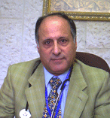  
Scientific Qualification:  
* Bachelor of medicine - Aristo University Greece   
* Specialization in Internal Medicine - Athena-Greece  
* Specialization in Nephrology - Athena-Greece  
* Jordanian Board in Internal Medicine and Nephrology  
  
Training Courses:  
Nottingham City Hospital – Nottingham-England  
  
Experiences:  
   
* Consultant of Internal Medicine and Nephrology in:  
- Al-Zarqa Government Hospital Princess Basma educational Hospital.  
- King Khalid Hospital / Hail- KSA  
- King Khalid /Tabouk-KSA  
* Since 1990 Doctor Hadad has owned private clinic and has been a consultant of Internal Medicine and Nephrology and Dialysis , Kidney transplantation in private sector hospitals in Irbid :  
- Rosary Hospital- Irbid  
- Ibn Al-Nafis Hospital   
- Al Qwasmi Hospital   
- Al-Najah Hospital  
- Consultant of Internal Medicine and Nephrology part time in Governmental Hospital.  
Membership:   
* Jordanian society of Nephrology.  
* European society of Nephrology.  
* International society of Nephrology  
* Arab society of Nephrology.**

**Dr. Bashar Mohammad Al-khasawneh**

**Personal Information:**

**Name: Dr. Bashar Mohammad Al-khasawneh 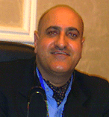  
Scientific Qualification:  
* Bachelor of Medicine and Surgery– Cairo University.  
* Jordan Board in Pediatrics.  
Training Courses:   
* Pediatric Board training at Jordan University Hospital .  
* Training courses and experiences in British ,American and Canadian Hospitals in Pediatric and Neonatology.  
* Participating in national and International conferences and workshops in Pediatric and Neonatology.  
  
Experiences:   
* Jordan Board in Pediatric.  
 Arab board training in Pediatric at Hammed General Hospital in Qatar.  
* Consultant Pediatrician and Neonatologist.  
* Consultant Pediatrician in Princess Basma Teaching Hospital.  
* Head of Neonatal Intensive Care Unit in Princess Basma Teaching Hospital.  
* Lecturer in Pediatrics and Neonatology at Jordan University of Science and Technology.   
* Private Clinic in Irbid.  
Membership:   
* Member of Jordanian Pediatric Society.  
* Member of Canadian Pediatric Society.  
* Member of American Pediatric Society.**

**Departments**

1. **The Outpatient and Antenatal Care Center**
2. **Laboratories**
3. **Financial Department**
4. **Labor and Delivery Room**
5. **Neonatal and Intensive Care Unit**
6. **Operating Rooms**
7. **Dialysis unit**
8. **I.V.F Unit Assisted Reproduction Medical (ARM)**
9. **Nutrition Department**

**Photos**

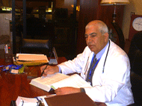 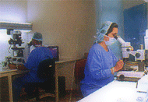 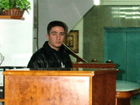

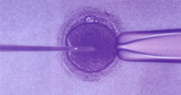

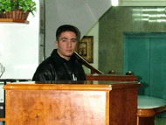**Contact us**

Jordan -Irbid  
Southern district - Iscan AL- Atiba  
Phone:7100171 **/** 7100170 **/** 7100176  
Fax:7100171  
Website: http://www.alnajah-hospital.com   
Email: info@alnajah-hospital.com